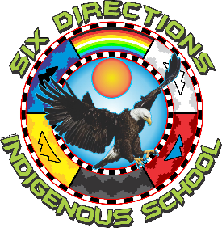

https://lh4.googleusercontent.com/0eIbwl32weN3WVv7suFRRtLPVM-Jo8KpwU0sCqjJrWgSdGHqcQ5lDsJH67gihnLFlu0a_JOUk84TMw1dPpNLqGy1iU7yLTpIPv9DiViiDJYBmSGy4SDOTPzlfkFsYYsuUdOmZvJZ2PaWTXcN7GXonvg

**2055 NM-602**

**Gallup, NM 87301**

**Phone:  505-863-1900  Fax:  505-863-8826**

**Special Session Public Notice**

**Date:** April 22, 2025  
 **Time:** 2:00 pm   
 **Location:** Six Directions Indigenous School  
 2055 NM-602, Gallup, NM 87301

**Notice is hereby given** that the Governing Council of Six Directions Indigenous School will hold a **Special Session** on the date listed above. The purpose of this meeting is to discuss matters pertaining to the **Head Administrator Evaluation**.

Pursuant to the Open Meetings Act, the Governing Council may enter into **Executive Session** to discuss limited personnel matters as authorized under NMSA 1978 Section 10-15-1(H)(2).

**Agenda:**

1. Call to Order
2. Roll Call
3. Approval of Agenda
4. Executive Session  
   * Discussion of Head Administrator Evaluation (Closed pursuant to NMSA 1978 §10-15-1(H)(2))
5. Return to Open Session  
   * Statement regarding matters discussed in Executive Session
6. Adjournment

This notice is given in compliance with the Open Meetings Act and the bylaws of the Governing Council of Six Directions Indigenous School.