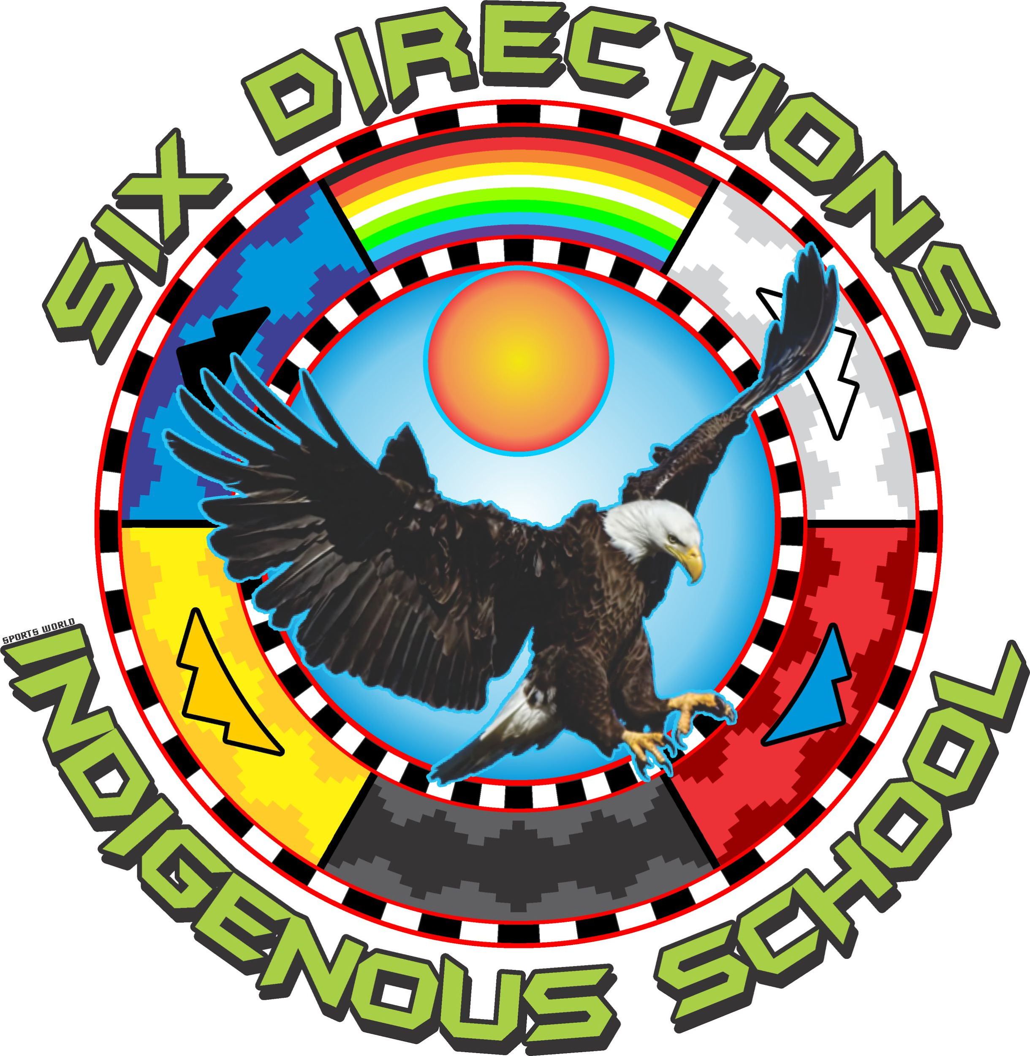
Six Directions Indigenous School
2055 NM – 602, Gallup, NM 87301
Phone: 505-863-1900 Fax: 505-863-8826

2024-2025 School Year Application
SDIS is a free Public Charter School, open to any student residing in New Mexico, grades 6th- 12th

Student Last Name First Name | Grade for 2024-2025 SY | Date of Birth
Does child have a sibling(s) attending SDIS? Yes ____ No ____ | If Yes, name of sibling(s)
Primary Parent/Guardian Relationship to Student | Phone # 1 | Phone # 2
Parent/Guardian Email Address

________________________ ________________________ DATE _______________
Parent/Guardian Signature Parent/Guardian Print Name

APPLICATION DEADLINE
For best chances submit Lottery Application early. SDIS will announce a series of Lottery Applications deadlines during late spring and summer 2024. Applications will be accepted throughout the school year for open seats or for a place on the waiting list.
Enrollment Process
- Submit Lottery Application
- In the event there is a Lottery wait list, SDIS will notify parent/guardians if they have been selected from the Lottery Application list
Please return Lottery Application to the SDIS main office. Thank you!

