

https://lh4.googleusercontent.com/0eIbwl32weN3WVv7suFRRtLPVM-Jo8KpwU0sCqjJrWgSdGHqcQ5lDsJH67gihnLFlu0a_JOUk84TMw1dPpNLqGy1iU7yLTpIPv9DiViiDJYBmSGy4SDOTPzlfkFsYYsuUdOmZvJZ2PaWTXcN7GXonvg

**2055 NM-602**

**Gallup, NM 87301**

**Phone: 505-863-1900 Fax: 505-863-8826**

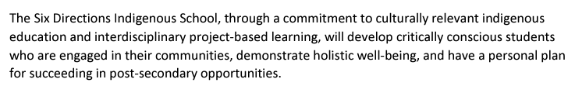

**Public Notice**

**Six Directions Indigenous School Special Session for Discussion and Action**

**Tuesday, December 10, 2024 at 5:30 pm**

**Six Directions Indigenous School**

1. **Call to Order**
2. **Roll Call**
3. **Invocation/Land Acknowledgement**
4. **Approval of Agenda**
5. **Approval of Minutes**
6. **Introduction of Guests**
7. **Discussion and Action Items**
   1. **Election of two governing council members Ray Daw and Wilhelmina Yazzie.**
   2. **Attendance of the governing council at the Public Charter Schools of New Mexico Conference in Santa Ana, New Mexico**
   3. **Approval of Work Session during the Public Charter Schools of New Mexico Conference in Santa Ana, New Mexico for Strategic Planning Meeting Session I from 3:30 - 5:00 pm for presentation of facilities by Troy Hunt, NACA Inspired Schools Network.**
   4. **Approval of Strategic Planning Meeting Session II at Six Directions Indigenous School on December 18, 2024 at 5:30pm**
8. **Future Board Meeting: December 31, 2024 at Six Directions Indigenous School at 5:30 pm.**

**Join Zoom Meeting**

[**https://zoom.us/j/99617982413?pwd=BaBq6raUia3AIHxKqaMkajY60pEgLl.1**](https://zoom.us/j/99617982413?pwd=BaBq6raUia3AIHxKqaMkajY60pEgLl.1)

**Meeting ID: 996 1798 2413**

**Passcode: SDIS**

**\*Public Comment will not be held during Special Meetings. Written comments accepted by Head Administrator** [**rebecca@sixdirectionsschool.org**](mailto:rebecca@sixdirectionsschool.org)**.**