

https://lh4.googleusercontent.com/0eIbwl32weN3WVv7suFRRtLPVM-Jo8KpwU0sCqjJrWgSdGHqcQ5lDsJH67gihnLFlu0a_JOUk84TMw1dPpNLqGy1iU7yLTpIPv9DiViiDJYBmSGy4SDOTPzlfkFsYYsuUdOmZvJZ2PaWTXcN7GXonvg

**2055 NM-602**

**Gallup, NM 87301**

**Phone: 505-863-1900 Fax: 505-863-8826**

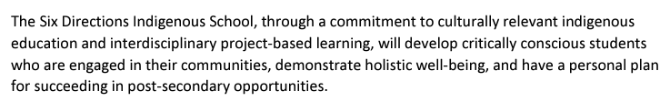

**Public Notice**

**Six Directions Indigenous School**

**Work Session**

**Friday, December 13, 2024 at 3:30 - 5:00 pm**

**1300 Tuyuna Trail, Santa Ana Pueblo, NM 87004**

**Six Directions Indigenous School Governing Council will conduct a Work Session during the Public Charter Schools of New Mexico Conference in Santa Ana, New Mexico for Strategic Planning Meeting Session I from 3:30 - 5:00 pm including presentation of facilities by Troy Hunt, NACA Inspired Schools Network.**